**VIRTUAL HARD DISC**

**EXPERIMENT - 08**

**AIM:** To create and configure a virtual hard disk (VMDK) in VMware Workstation and allocate storage space for a virtual machine.

**Procedure:**

1. Open VMware Workstation (or VMware Player) on your computer and click Create a New Virtual Machine from the main window.
2. Choose either Typical (recommended) or Custom setup based on your preference, then click Next to continue.
3. Select the installation method (e.g., ISO file or physical disk) or choose to install the OS later, then click Next.
4. Enter a name for your virtual machine and choose a location on your system where the VM files will be saved.
5. When prompted to specify disk capacity, enter the desired size for the virtual hard disk (e.g., 20 GB). Decide whether to store the virtual disk as a single file or split into multiple files for easier portability.
6. Click Next and review your settings in the summary page. If everything looks correct, click Finish to create the VM.
7. To view or modify the virtual hard disk, select the VM, click Edit virtual machine settings, then select the Hard Disk from the list. You can change size, add additional disks, or adjust options like disk mode and caching.
8. Finally, power on the virtual machine to ensure the hard disk is detected properly by the guest operating system.

**OUTPUT:**

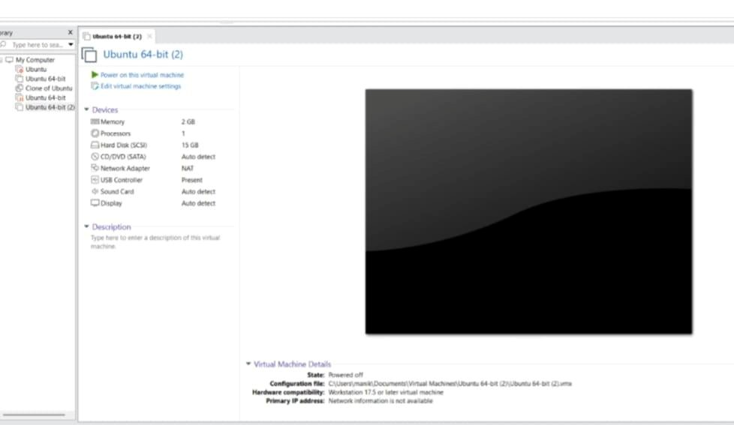

**RESULT:** Thus, a virtual hard disk has been successfully created and allocated in VirtualBox, ready to be used with the virtual machine.